# Says Thinks

Healthcare supply chain is a complex network of several

independent entities

### The importance of drug traceability (track and trace) is

increasingly emphasized and mandated by several countries

Healthcare supply chains are complex structures spanning across multiple organizational

and geographical boundaries,

across the world.

We propose a blockchain-based solution for the pharmaceutical supply chain that provides security, traceability,

## immutability, and accessibility of data provenance for

### pharmaceutical drugs.

we have investigated the challenge of drug

### traceability within pharmaceutical supply chains highlighting

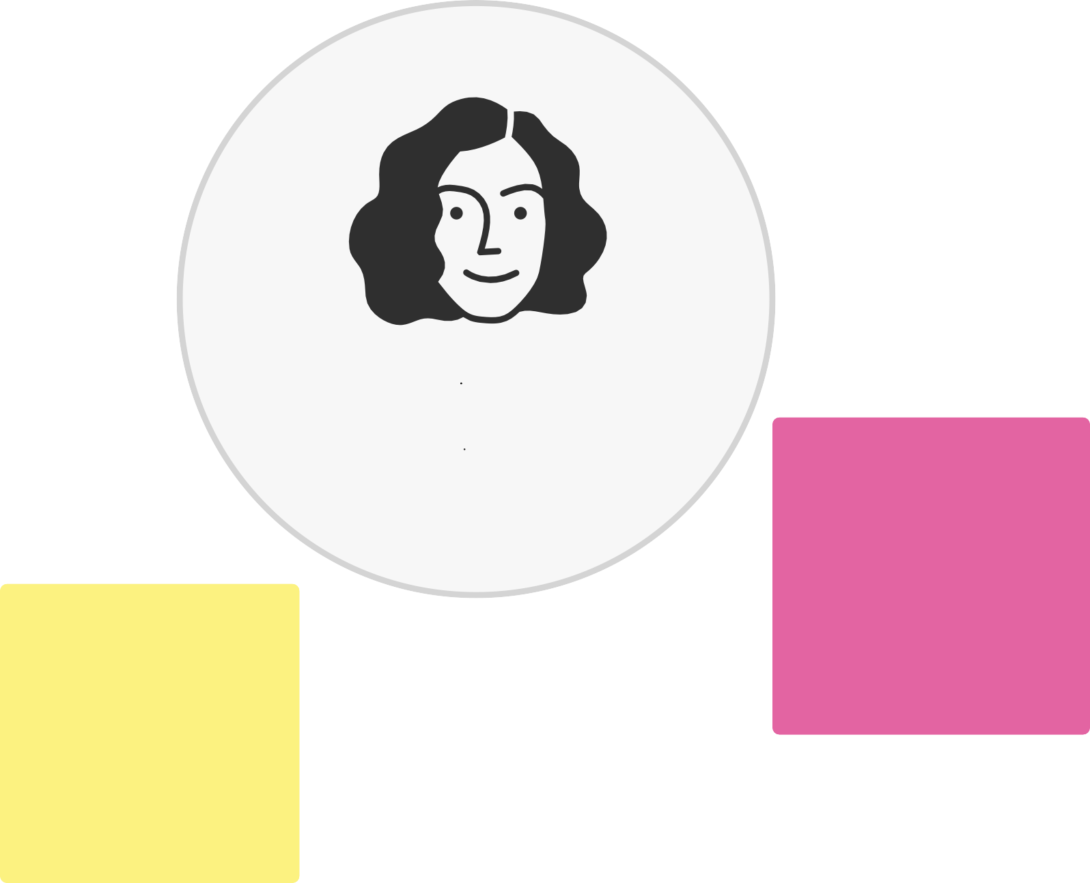

its significance especially to protect against counterfeit drugs.

# Does Feels

What are their fears, frustrations, and anxieties? What other feelings might influence their behavior?

[**See an example**](https://app.mural.co/template/8734e26b-e4c9-45b9-a5ba-03ce4aa3c700/ca1d645e-05be-4feb-94bb-f670d5f20e7c)